Assignment 7

Task Description 1

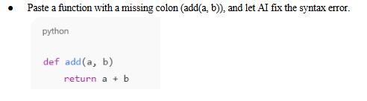

Code:

A = input("Enter value for A: ")
B = input("Enter value for B: ")
print(float(A) + float(B))

Practical Output:

Task Description 2

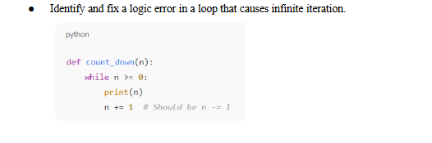

Code:

n = int(input("Enter value for n: "))
def count_down(n):
while n >= 0:
print(n)
n -= 1 # Decrement n by 1 each loop
print(count_down(n))

Practical Output:

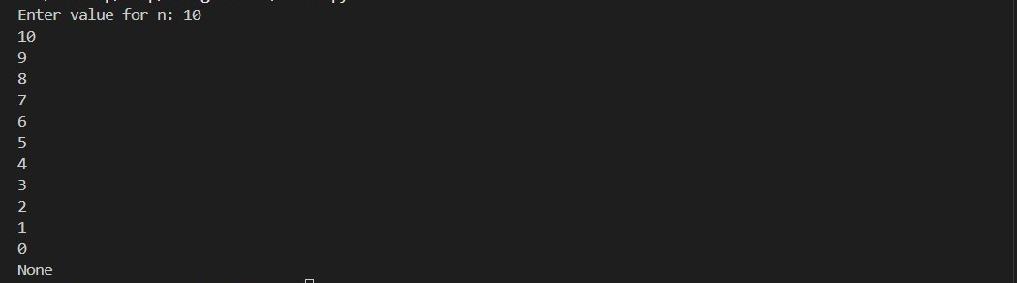

Task Description 3

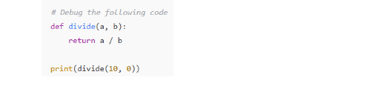

Code:

def divide(a, b):
try:
return a / b
except ZeroDivisionError:
return "Error: Division by zero is not allowed."
except TypeError:
return "Error: Both inputs must be numbers."

print(divide(10, 0))

Practical Output:

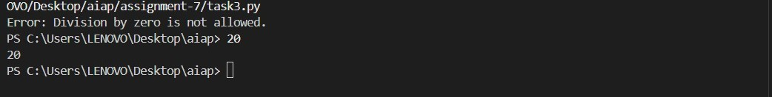

Task Description 4

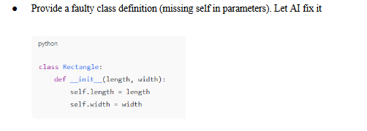

Code:

class Rectangle:
def __init__(self, length, width):
self.length = length
self.width = width

r1 = Rectangle(10, 5)
print(r1.length) # Output: 10
print(r1.width) # Output: 5

Practical Output:

Task Description 5

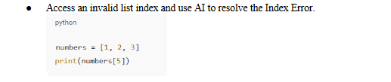

Code:

numbers = [1, 2, 3]

try:
print(numbers[5])
except IndexError:
print("Invalid index! Please select a valid position.")

Practical Output:

